Light in our darkness
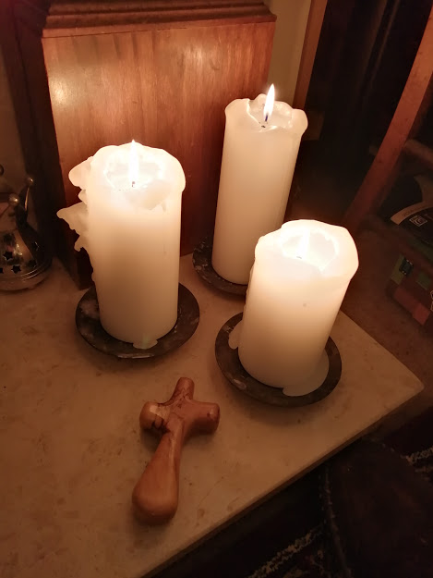

Resource for worship week 1

You will need a candle, battery operated or otherwise and a cross.

Psalm 27:1 ‘The Lord is my light and my salvation – how shall I fear?’

Read through slowly Mark 15:33-39

³³ At noon, darkness came over the whole land until three in the afternoon. ³⁴ And at three in the afternoon Jesus cried out in a loud voice, “Eloi, Eloi, lema sabachthani?” (which means “My God, my God, why have you forsaken me?”).^{[a]}
³⁵ When some of those standing near heard this, they said, “Listen, he’s calling Elijah.”
³⁶ Someone ran, filled a sponge with wine vinegar, put it on a staff, and offered it to Jesus to drink. “Now leave him alone. Let’s see if Elijah comes to take him down,” he said.
³⁷ With a loud cry, Jesus breathed his last.
³⁸ The curtain of the temple was torn in two from top to bottom. ³⁹ And when the centurion, who stood there in front of Jesus, saw how he died,^{[b]} he said, “Surely this man was the Son of God!”

Reflection:

It ought to have been a time of light but the world was plunged into darkness. The disciples were fearful. In a matter of moments their world had been shattered and they could not understand what was happening. Everything was falling apart; nothing would be the same again. In the midst of their confusion was one lone cry, ‘My God, my God why have you forsaken me.’ The light of the world is slain by darkness – and where was God?
The truth is that God was in their midst and with the death of Jesus the curtain that separated was ripped asunder from top to bottom.
At present it feels like we are in darkness, separated from one another, fearful and anxious, wondering where is God in all this? But he is right with us. He is the light that overcomes the darkness, the hope that drives away our fear and despair. We bring to him our anxious thoughts, our doubts and fears, our loneliness and despair. He takes it all upon himself, he bears our burdens and proclaims, ‘let there be light!’ He is the Son of God, the Light of the world and our Saviour. He promises to be with you, to comfort and uphold you, to watch over you and keep you safe.

Take a candle and place it before the cross. Light it and think of the Lord being the light in our darkness. Take a moment to offer to him your concerns for yourself and others. You may want to say the following prayers.

God of compassion,
be close to those who are ill, afraid or in isolation.
In their loneliness, be their consolation;
in their anxiety, be their hope;
in their darkness, be their light;
through him who suffered alone on the cross,
but reigns with you in glory,
Jesus Christ our Lord.
Amen.

A prayer for those who are isolated

O God, help me to trust you,
help me to know that you are with me,
help me to believe that nothing can separate me from your love
revealed in Jesus Christ our Lord.
Amen.

A prayer for our community

We are not people of fear: we are people of courage.
We are not people who protect our own safety:
we are people who protect our neighbours’ safety.
We are not people of greed: we are people of generosity.
We are your people God, giving and loving,
wherever we are, whatever it costs
For as long as it takes, wherever you call us.
Amen.

A song to sing or reflect on:
https://www.youtube.com/watch?v=ZJq3bhdgQoc

Longing for light, we wait in darkness.
Longing for faith, we turn to you.
Make us your own, your holy people
Light for the world to see.
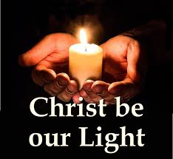

Christ be our light! Shine in our hearts
Shine through the darkness.
Christ be our light!
Shine in your church gathered today.

Longing for peace, our world is troubled.
Longing for hope, many despair.
Your word alone has power to save us.
Make us your living voice.

Christ be our light! Shine in our hearts
Shine through the darkness.
Christ be our light!
Shine in your church gathered today.

Many the gifts, many the people,
Many the hearts that yearn to belong.
Let us be servants to one another,
Making your kingdom come.
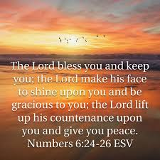

Christ be our light! Shine in our hearts
Shine through the darkness.
Christ be our light!
Shine in your church gathered today.

Closing prayer

May the Lord bless you and keep you.
The Lord make his face to shine upon you and be gracious to you.
The Lord turn his face towards you and give you peace.

Go in peace to love and serve the Lord.
Thanks be to God.

