God’s Faithfulness

Resource for worship week 5

You will need a mirror and a cross.

Jeremiah 29:13 ‘For I know the plans I have for you,’ declares the Lord.
‘Plans to prosper you and not to harm you. Plans to give you hope and a future.’

Read through slowly the verses from Psalm 139 below:

¹ You have searched me, Lord, and you know me.
² You know when I sit and when I rise; you perceive my thoughts from afar.
³ You discern my going out and my lying down; you are familiar with all my ways.
⁴ Before a word is on my tongue you, Lord, know it completely.
⁷ Where can I go from your Spirit? Where can I flee from your presence?
⁸ If I go up to the heavens, you are there; if I make my bed in the depths, you are there.
⁹ If I rise on the wings of the dawn, if I settle on the far side of the sea,
¹⁰ even there your hand will guide me, your right hand will hold me fast.
¹³ For you created my inmost being; you knit me together in my mother’s womb.
¹⁴ I praise you because I am fearfully and wonderfully made;
¹⁵ My frame was not hidden from you when I was made in the secret place,
when I was woven together in the depths of the earth,
¹⁶ Your eyes saw my unformed body;
all the days ordained for me were written in your book before one of them came to be.
¹⁷ How precious to me are your thoughts, God! How vast is the sum of them!
¹⁸ Were I to count them, they would outnumber the grains of sand—
when I awake, I am still with you.

Reflection:
At this time when everything is unsettled, it is good to reflect on God’s knowledge of us and love for us. There is no part of our lives, which God does not see, no time in our lives when God is not present. Every moment of every day God is with us. He weeps with us, rejoices with us, is saddened by our unkindness and gladdened by the good we do. God has such wonderful plans for us to make us pure and holy, glorious in his presence, shining like the stars.
Mallard Ducking by Paul Beech.

He never stops thinking about you. He longs to take us up in his arms and carry us into eternity, for you are precious in his sight.

Prayer Activity
Take a moment to look at yourself in the mirror. Reflect on God’s love for you. You are beautiful in his sight. Think about your life, your character and your situation. Entrust all your cares and concerns to your heavenly Father and pray for his love to be poured out on you. Think about your future plans. Commit them to the Lord for his blessing. Think about your family and friends. Pray for God’s love to be made real to them.
You may wish to use the following poem as a basis for prayer:

God loves you by Edwina Gateley

Be silent.
Be still.
Alone. Empty.
Before your God.
Say nothing.
Ask nothing.
Be silent.
Be still.
Let your God look upon you.
That is all.
God knows.
God understands.
God loves you with an enormous love.
God only wants to look upon you
With love.
Quiet.
Still.
be.
Let your God love you.

Time of prayer
Heavenly Father,
You see me as I really am
You know me through and through
You see all that I am or ever have been.
Every experience in my life is laid before you.
every word, thought and action is known to you.
Lord of love, I entrust myself to you

You knew me at the moment of my creation.
You have watched over me from my earliest days
You know me better than I know myself and You love me.
You love me utterly and eternally
Nothing and no one can separate me from your love.
Lord of love, I entrust myself to you

I praise and thank you for your presence in my life.
I give you my heart and all my deepest feelings.
I give you my stillness and my busyness.
I give you every relationship, every situation and circumstance
I give you all my searching and striving after truth.
I give you all my ignorance, my questions and doubts.
Lord of love, I entrust myself to you

I thank you for my family and friends,
With whom I have shared such sweet memories.
I thank you for the difficult people in my life
Who have made me stronger, more patient and forgiving.
I thank you for answering my prayers and providing for all my needs.
I thank you for those I have helped and who have helped me.
Lord of love, I entrust myself to you

Father, may I know the radiance of your love upon my life.
Help me to know what joy my response brings to You.
Give me the grace in my weakness to cry 'Abba', Father.
Refresh me, Renew me. Come and dwell within me.
Let me use the gifts you have given me,
To serve others and bring glory to you.
May the fruit of your Spirit be evident in my life
That I may be a fountain of your blessing.
Lord of love, I entrust myself to you

A song to sing or reflect on:
Charles Wesley.
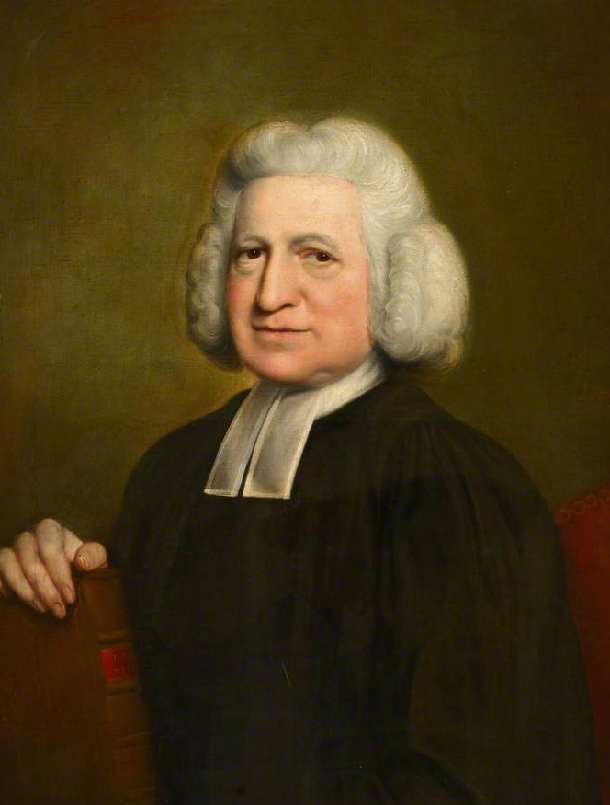
Love divine, all loves excelling
Joy of heaven, to earth come down:
Fix in us thy humble dwelling,
All they faithful mercies crown.

Jesus, Thou art all compassion
Pure, unbounded love Thou art;
Visit us with Thy salvation
Enter every trembling heart.

Breathe, O breathe Thy loving Spirit
Into every troubled breast;
Let us all in Thee inherit,
Let us find Thy promised rest.

Take away the love of sinning,
Alpha and Omega be;
End of faith as its beginning,
Set our hearts at liberty.

Come, almighty to deliver,
Let us all Thy grace receive;
Suddenly return and never,
Never more Thy temples leave.

Thee we would be always blessing,
Serve Thee as Thy hosts above
Pray and praise Thee without ceasing,
Glory in Thy perfect love.

Finish then Thy new creation
Pure and spotless let us be;
Let us see Thy great salvation,
Perfectly restored in Thee:

Changed from glory into glory,
Till in heaven we take our place,
Till we cast our crowns before Thee,
Lost in wonder, love and praise.

Closing prayer
May God give to you and to all those you love
His comfort and peace,
His light and his joy,
In this world and the next;
And may the blessing of God almighty,
the Father, the Son and the Holy Spirit,
be with you all this day and for ever more.

Go in peace to love and serve the Lord.
Thanks be to God.

