Ascension Day

Resource for worship week 8
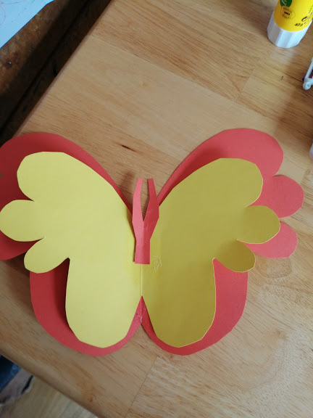

You will need a cross and a butterfly
(you may have a manufactured one or wish to make/ design your own, here is mine made in 2 minutes from this YouTube video, https://www.youtube.com/watch?v=g10lSxvallI ).

Opening verse:
‘Jesus was taken up before their very eyes, and a cloud hid him from their sight.’ Acts 1:9

Read through slowly the verses from Psalm 47 below:

¹Clap your hands, all you nations; shout to God with cries of joy.

² For the Lord Most High is awesome, the great King over all the earth.

⁵ God has ascended amid shouts of joy, the Lord amid the sounding of trumpets.
⁶ Sing praises to God, sing praises; sing praises to our King, sing praises.

⁷ For God is the King of all the earth; sing to him a psalm of praise.

⁸ God reigns over the nations; God is seated on his holy throne.
⁹ The nobles of the nations assemble as the people of the God of Abraham,
for the kings of the earth belong to God; he is greatly exalted.

Reflection:

When I was a university student, I collected some Privet Hawk larvae and nurtured them for many weeks until they eventually became large enough to pupate. After some time, they began to break out of their cocoon and I had the joy of releasing them into a nearby wood. It was an exhilarating feeling to witness these beautiful moths, which for a time had been confined in a vivarium, suddenly take flight and ascend into the sky, free and unconstrained. It was like setting a bird free from it’s cage or sending a rocket soaring into the heavens or releasing a festival of balloons into the blue sky.
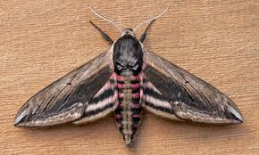

At this time, I’m reminded of our Lord Jesus, who took upon himself our humanity. Confined to the limitations of our human nature, he consented to bearing our pain and suffering and then he humbled himself further, even to the point of being nailed to a cross. He lay in the grave, a stone rolled across the tomb for three days, until gloriously he rose, triumphant over death. On the day of ascension our Lord finally threw off the shackles and ascended amidst shouts of joy into the heavens, where he now reigns at his Father’s right hand. In reading the psalm above, I can sense the joy and excitement of his ascension, the feeling of fulfilment and his return to glory, building to a crescendo of praise and rejoicing.

Jesus has returned to glory and he is even now preparing for the great day when he will welcome us, unconstrained, unlimited and unbound into his joyous presence, where we will live forever more. ‘Sing praises to God, sing praises; sing praises to our King, sing praises.’

Ascension by Malcolm Guite:

We saw his light break through the cloud of glory
Whilst we were rooted still in time and place
As earth became a part of Heaven’s story
And heaven opened to his human face.
We saw him go and yet we were not parted
He took us with him to the heart of things
The heart that broke for all the broken-hearted
Is whole and Heaven-centred now, and sings,
Sings in the strength that rises out of weakness,
Sings through the clouds that veil him from our sight,
Whilst we our selves become his clouds of witness
And sing the waning darkness into light,
His light in us, and ours in him concealed,
Which all creation waits to see revealed.
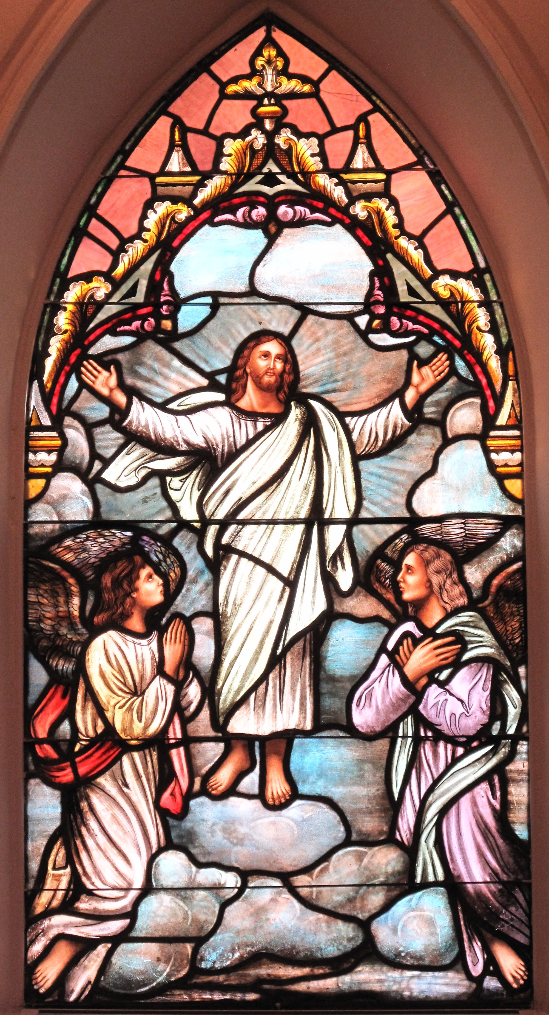

Prayer Activity
Take a moment to think about our Lord’s ascension. Think of the transformation of a caterpillar into a butterfly. Think of a time when you set something free.
Place your butterfly before the cross. Give thanks for the Lord Jesus and the hope that awaits us in heaven. Ask the Lord to send his Spirit of joy and hope into your life and the lives of those you care for. You may wish to use the following prayer:

Lord Jesus, the only comfort and joy of our souls;
Look upon us with loving kindness,
Embrace us in your arms of mercy,
Open our eyes to see you and our ears to hear you,
Open our lips to praise you and our hearts to receive you.
Pour your Holy Spirit into our hearts,
that we might know you are with us now;
Lift up our minds that we may behold the glory
that awaits us in heaven and hope of eternal life. Amen.

Time of prayer

Grant, we pray, Almighty God,
that as we believe your only-begotten Son our Lord Jesus Christ
to have ascended into the heavens;
so we in heart and mind may also ascend,
and with him continually dwell,
who is alive and reigns with you
in the unity of the Holy Spirit,
one God, now and for ever. Amen.

Heavenly Father,
We thank you for the promise that you have prepared many rooms for us.
At this time many are fearful of the future;
Help us to turn to you in faith
and to trust in your promises, which never fail
That we may rest secure in the knowledge of your love
And of the glorious resurrection of your Son, our Saviour Jesus Christ.
Lord in your mercy, hear our prayer

Prayer for Creation
Lord Jesus, Lord of all creation
In this time of pandemic,
Your creation is receiving a Sabbath of rest;
Pollution levels are falling, deforestation is slowing
Nature is slowly beginning to recover.
As we seek to return to work may we be conscious
of the need to continue to care for the earth
and to live in harmony with all creation.
Lord in your mercy, hear our prayer.

Prayer for Schools
Heavenly Father,
We pray for our schools, colleges and universities
Our teaching staff, administrators, cooks, cleaners and caretakers;
Sustain, provide and protect them at this time;
Bless our children and their parents and carers,
Keep them safe and well.
Lord in your mercy, hear our prayer.
Prayer for patience
Gracious Father,
Many are anxious to return to normal working
And the lifting of restrictions.
Keep us patient, waiting upon your timing
Knowing that actions taken in haste can set us back
And lead to greater suffering and distress.
Help us to rest in you and find peace in your presence.
Lord in your mercy, hear our prayer

Prayer for the sick and grieving
Lord of all compassion,
We pray for those who are struggling and suffering at this time,
Who find each day a burden instead of a joy,
And each moment a battle to fight instead of a time for peace
Draw near and calm the storms of our lives
That we may find rest and quiet in your sovereignty.
Lord in your mercy, hear our prayer

Let us commend ourselves and all for whom we pray
to the mercy and protection of God, in the prayer our Saviour taught us.

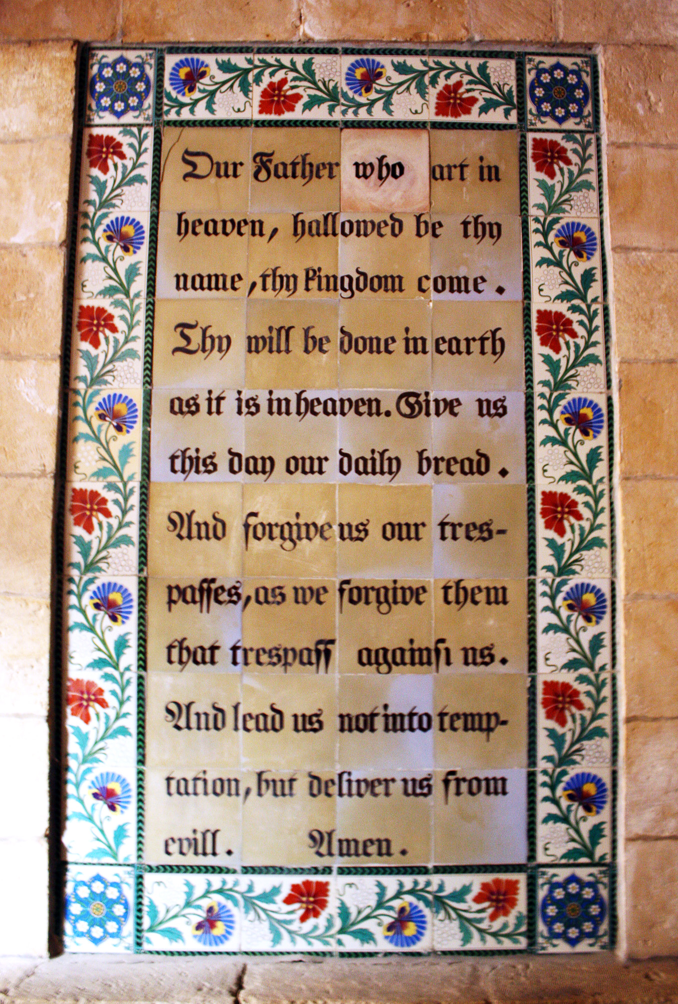
Our Father who art in heaven,
Hallowed be thy name.
Thy kingdom come, thy will be done
On earth as it is in heaven.
Give us this day our daily bread
And forgive us our trespasses
As we forgive those who trespass against us.
And lead us not into temptation but deliver us from evil
For thine is the kingdom, the power and the glory
For ever and ever. Amen.

A song to sing or reflect on:

Look ye saints the sight is glorious,
See the Man of sorrows now
From the fight returned victorious
Every knee to Him shall bow:
Crown Him! Crown Him!
Crown Him! Crown Him!
Crowns become the victor’s brow.

Crown the Saviour, angels crown Him!
Rich the trophies Jesus brings;
In the seat of power enthrone Him,
While the vault of heaven rings:
Crown Him! Crown Him!
Crown Him! Crown Him!
Crown the Saviour King of kings!

Sinners in derision crowned Him,
Mocking thus the Saviour’s claim;
Saints and angels crowd around Him,
Own His title, praise His name:
Crown Him! Crown Him!
Crown Him! Crown Him!
Spread abroad the victor’s fame.

Hark, those bursts of acclamation!
Hark, those loud triumphant chords!
Jesus takes the highest station:
O what joy the sight affords!
Crown Him! Crown Him!
Crown Him! Crown Him!
King of kings, and Lord of lords!

Closing prayer
May Christ, who has opened the kingdom of heaven,
Bring us to reign with Him in glory. Amen.

Go in peace to love and serve the Lord.
Thanks be to God.

