Trinity

Resource for worship week 10

You will need a cross and three ribbons or cord woven together to make one plait.

Opening verse:

‘Because you are sons, God has sent forth the Spirit of His Son into our hearts.’ Galatians 4:6

Read through slowly the verses from Matthew 3:13-17 below:

¹³ Then Jesus came from Galilee to the Jordan to be baptized by John.
¹⁴ But John tried to deter him, saying, “I need to be baptized by you, and do you come to me?”
¹⁵ Jesus replied, “Let it be so now; it is proper for us to do this to fulfil all righteousness.” Then John consented.
¹⁶ As soon as Jesus was baptized, he went up out of the water. At that moment heaven was opened, and he saw the Spirit of God descending like a dove and alighting on him.
¹⁷ And a voice from heaven said, “This is my Son, whom I love; with him I am well pleased.”

Reflection:
The concept of the Trinity, one God in three persons, is difficult to grasp. We are trying to comprehend the incomprehensible. But in the baptism of Jesus we see this dynamic in action, the Spirit of God alighting on the Son of God as he comes out of the water, to receive the pleasure of God the Father, ‘this is my Son whom I love; with him I am well pleased.’
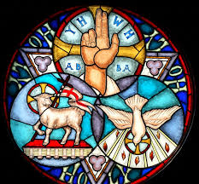
In Jesus’ baptism we see the whole Godhead reaching out to sinful humanity in pure love.
As Jesus takes upon himself our life, our baptism, so we glimpse the holy mystery – that in Jesus we are anointed by the Spirit of God and become children of God, loved by the Father.

One day a poor man requested an audience with the King that he might receive help. The King sent his son to talk with the poor man and promise him he would indeed help. In token of his word, the prince gave the man his own signet ring. He said to the man, ‘my ring gives you authority to request me at any time and I will bring your needs to my Father the king.’
The Holy Spirit is our deposit given to us by our Prince, the Lord Jesus, to show his favour towards us and to assure us of our access to the King.

God loves you. God the Father, God the Son and God the Holy Spirit love you, with the same eternal love.

Poem: Trinity by Malcolm Guite:

Beginning here we glimpse the Three-in-one;
The river runs, the clouds are torn apart,
The Father speaks, the Sprit and the Son
Reveal to us the single loving heart
That beats behind the being of all things
And calls and keeps and kindles us to light.
The dove descends, the spirit soars and sings
‘You are belovèd, you are my delight!’
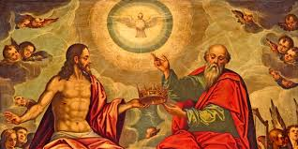
In that quick light and life, as water spills
And streams around the Man like quickening rain,
The voice that made the universe reveals
The God in Man who makes it new again.
He calls us too, to step into that river
To die and rise and live and love forever.

Prayer Activity
Take a moment to think about the Trinity. Hold your plait of three ribbons. The scriptures say ‘a cord of three strands is not easily broken.’
Remember that God the Father loves you. He created you in love. He has watched over you from the moment of your conception. He knows you better than you know yourself. Remember God the Son loves you. He died for you and he lives for you. Remember God the Spirit loves you. He is with you always. He is in you always, supporting and upholding you; mourning with you and rejoicing with you. In the silence give yourself to the love of God.

You may wish to say the following prayer.

Gracious Father, you have known me
and loved me from the very beginning.
In this moment may I know your complete love for me.
May I behold your hand upon my life,
Guiding, protecting, supporting and comforting.
Show me your face that I may behold your smile,
And know you are pleased with me.

Lord Jesus, I bow down before you as I see you on your Cross
I see your arms stretched out
seeking to embrace the whole world,
seeking to embrace me, seeking to love me,
seeking to forgive me, seeking to make me whole.

Holy Spirit, pour your cleansing streams of living water all over me.
Make the parched deserts of my being spring to life.
Refresh me, Renew me.
Lord breathe on me afresh now and I will receive your life.
Reach out and touch me and I will receive your healing.
Empty me utterly of all doubt and unbelief of your love for me.

Bring me into the deep silence of your presence.
May I become your dwelling place.
Fill me with the reality of your living presence.
In this moment may I find my true rest in you, now and always. Amen.

Time of prayer

Gracious Lord, as we begin the eleventh week of lockdown,
We continue to pray

For the health and well-being of our nation,
that all who are fearful and anxious
may be at peace and free from worry:
Lord, hear us,
Lord, graciously hear us.

For the isolated and housebound,
that we may be alert to their needs,
and care for them in their vulnerability:
Lord, hear us,
Lord, graciously hear us.
For our homes and families,
our schools and young people,
and all in any kind of need or distress:
Lord, hear us,
Lord, graciously hear us.
For a blessing on our local community,
that our neighbourhoods
may be places of trust and friendship,
where all are known and cared for:
Lord, hear us,
Lord, graciously hear us.
For the sick, the outcast, the dying and the grieving
That they may know your love and compassion
And that we may comfort and support them
In our actions and our prayers.
Lord, hear us,
Lord, graciously hear us.
Let us commend ourselves and all for whom we pray
to the mercy and protection of God, in the prayer our Saviour taught us.

Our Father who art in heaven,
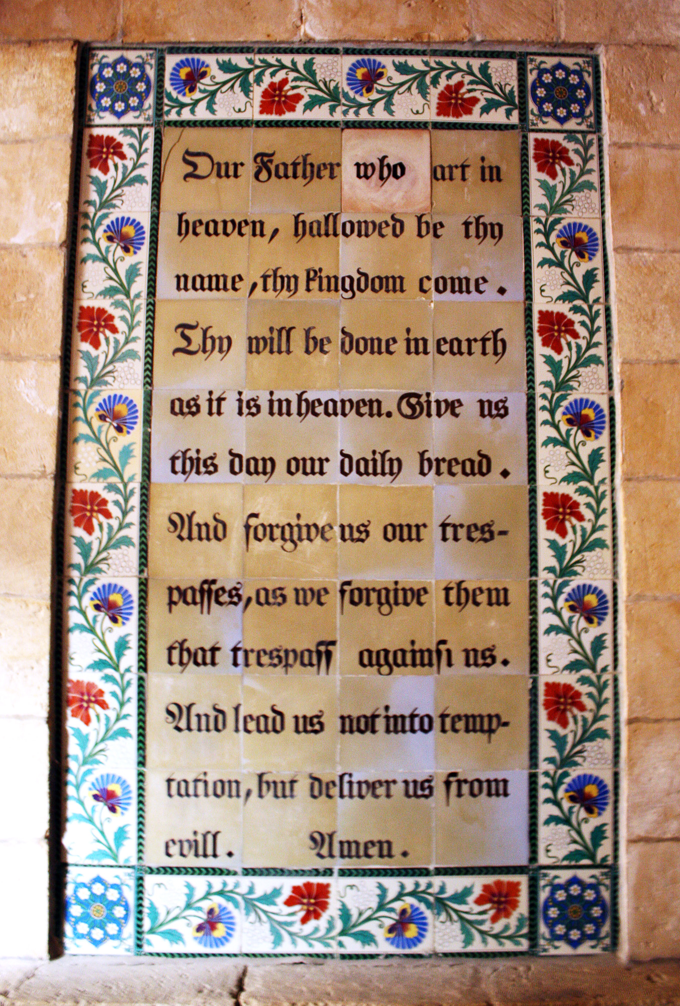
Hallowed be thy name.
Thy kingdom come, thy will be done
On earth as it is in heaven.
Give us this day our daily bread and forgive us our trespasses
As we forgive those who trespass against us.
And lead us not into temptation but deliver us from evil
For thine is the kingdom, the power and the glory
For ever and ever. Amen.

A song to sing or reflect on:

There is a Redeemer,
Jesus, God’s own Son
Precious lamb of God, Messiah,
Holy One
Thank You, O my Father,
For giving us Your Son,
And leaving Your Spirit,
Till the work on earth is done.

Jesus, my Redeemer,
Names above all names,
Precious Lamb of God, Messiah,
O for sinners slain:

Chorus

When I stand in glory
I will see His face,
And there I’ll serve my King for ever
In that holy place.
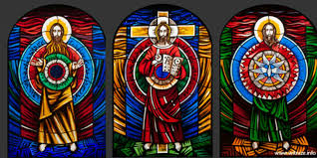

Chorus

Closing prayers
The Lord God Almighty, Father, Son and Holy Spirit,
The holy and undivided Trinity,
Guard you, save you,
And bring you to that heavenly city,
Where he lives and reigns for ever and ever. Amen.

May the grace of our Lord Jesus Christ and the love of God and
the fellowship of the Holy Spirit be with you all. Amen.

Go in peace to love and serve the Lord.
Thanks be to God.

