Sutton Parish Update July 2020

Wonderful News! St James extension has now been completed!!
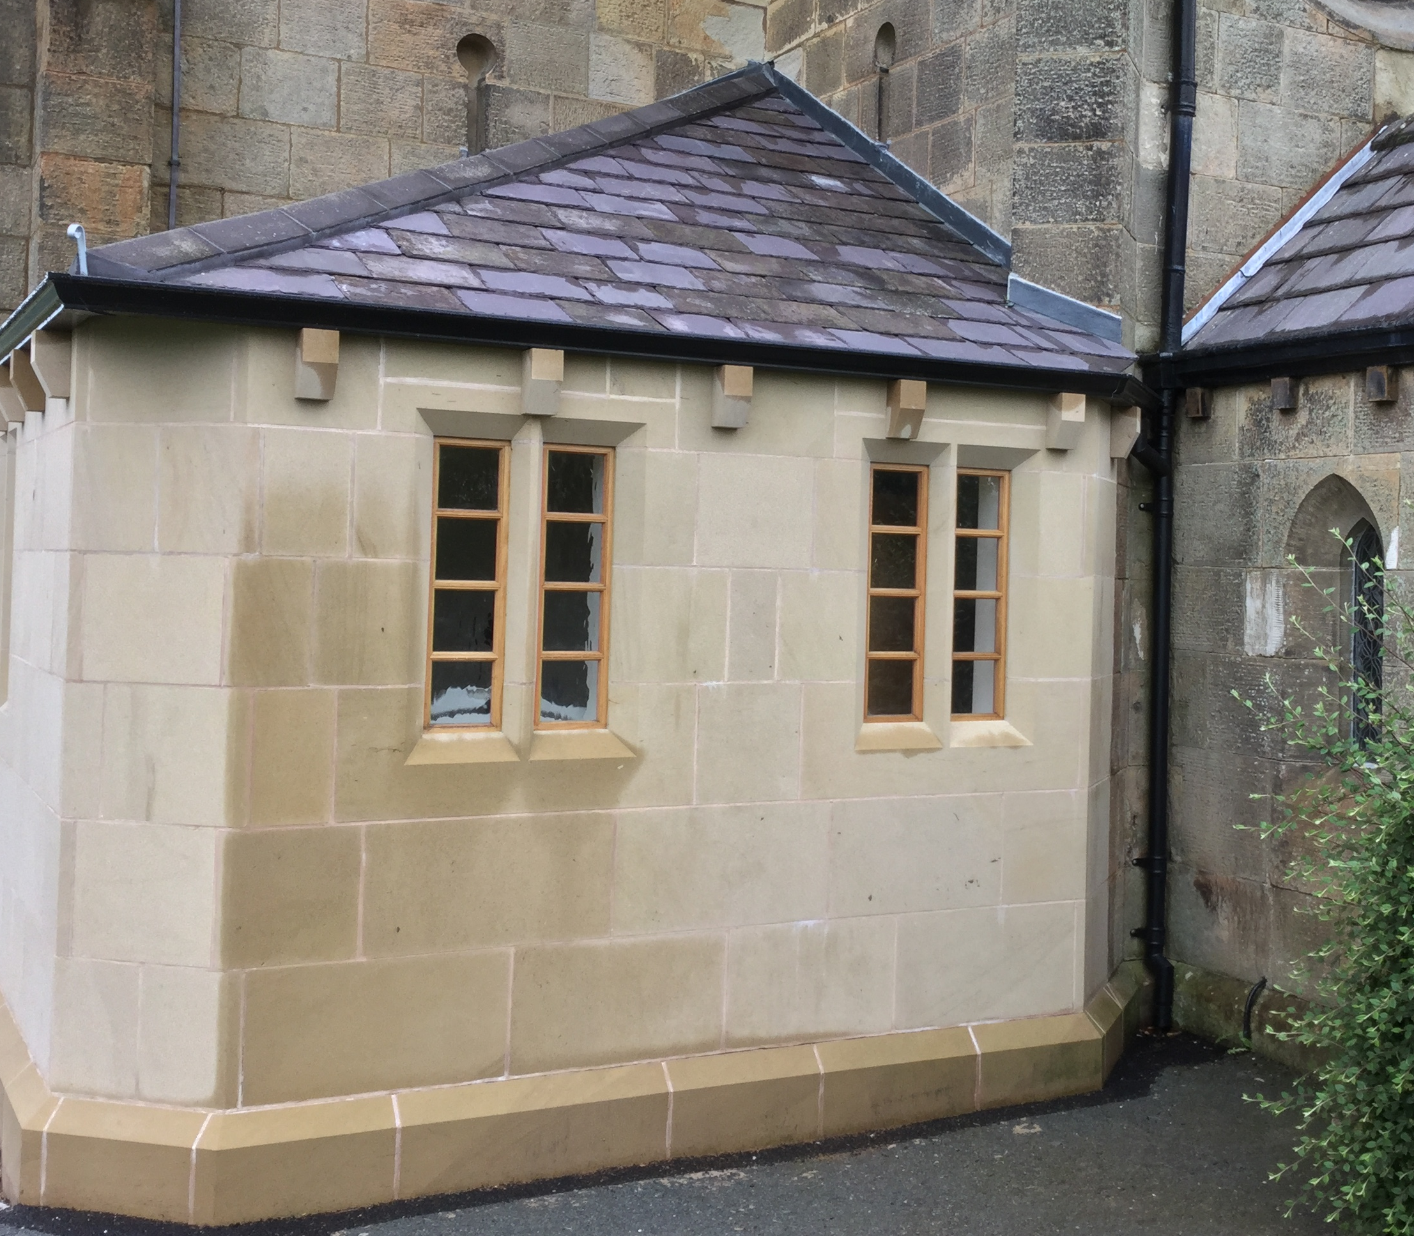

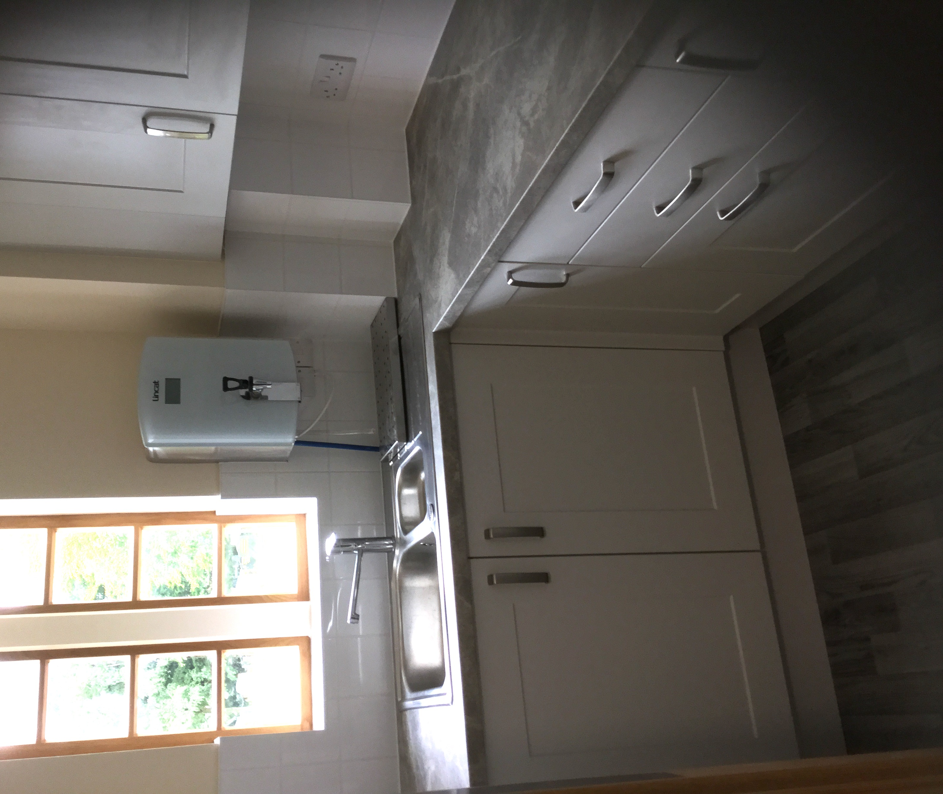

After overcoming many obstacles, hurdles and delays we can announce that the toilet and kitchen extension at St James Church is now finished. And like the Tardis, it looks bigger inside! The toilet has been designed for universal access and also has a baby change facility. The kitchen is compact and will enable us to provide refreshments in church as needed.

We are now in a position to cautiously reopen St James for private prayer from Sunday 19th July. Initially the church will only be accessible from 10am – 4pm on Wednesdays and Sundays. Appropriate guidelines, notices and sanitiser will be provided to ensure your safety and peace of mind, whilst you are in church.

We plan to open St James church for services from 6th September. We appreciate that many have been waiting for a long time and want to get back to normal as soon as possible. However, we want to be able to provide worshipful services that are safe, sustainable and have some resemblance to the services we enjoy so much. At present this is difficult due to social distancing, not being able to sing or share fellowship. We also need to carefully plan how we are to provide communion in the ‘new normal.’

I would ask for your patience and understanding at this time as we seek to ensure our times together are uplifting, supportive and safe.
Services will continue to be provided online through Facebook and Youtube which can be accessed through our website www.peakparishes.org.uk.

Thank you and keep safe

Revd John Harries

