Pentecost
Resource for worship week 9

You will need a cross and a dove or symbol of peace

As we begin our worship this week looking to the coming of Pentecost, we give thanks to God for the recent appointment of Rt Rev Mark Tanner to be the next Bishop of Chester. More information on Mark and his family can be found on the Chester diocesan website. We begin with a prayer for our new bishop.

Gracious Lord, who as at this time of Ascension,
was exalted to the highest throne
and did distribute to your people every good gift
for the edification of your church.
We give thanks for the appointment of Bishop Mark
as the new bishop of Chester;
endue him with your gifts of grace and wisdom
that, filled with your Spirit, he may walk continually in your paths
and lead us in the way of truth and eternal life. Amen.

Opening verse:
‘God has poured out his love into our hearts by the Holy Spirit, whom he has given us .’
Romans 5:5

Read through slowly the verses from Acts 2:1-4 below:

¹When the day of Pentecost came; they were all together in one place.

² Suddenly a sound like the blowing of a violent wind came from heaven and filled the whole house where they were sitting.

³ They saw what seemed to be tongues of fire that separated and came to rest on each of them.

⁴ All of them were filled with the Holy Spirit and began to speak in other tongues as the Spirit enabled them.

Reflection:
When I think of that first Pentecost my thoughts are drawn to the taking up of Elijah into heaven. You may recall the chariots and horses of fire that appeared and separated Elijah from Elisha, and then Elijah was taken up to heaven in a whirlwind. It was heaven breaking through into our world. On that first Pentecost, we likewise have heaven breaking into our world; the sound of a violent wind and tongues of fire coming to rest on the disciples. But this time, the disciples were not taken up but the Spirit came down and filled them. It was a clear indication that their ministry was not finishing but just beginning. They were to go forth into all the world and proclaim the gospel of forgiveness and peace.

God chooses ordinary people to be bearers of extraordinary news. Our God is calling us home, back into his arms of love. Despite our sin, the mistakes in our lives, the hurt we have caused and the grief to our Lord’s heart – God has forgiven us and sent his Spirit to dwell in our hearts. As God broke into the lives of the first disciples at Pentecost, so he breaks into our lives today and sends us out into all the world with his message of peace and reconciliation.
How beautiful are the feet of those who brings good news! This week let us reflect on the love of God in saving us and in choosing us to be his messengers of peace.

Pentecost by Malcolm Guite:
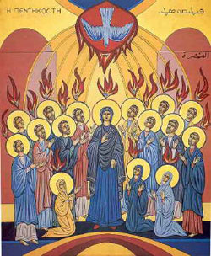
Today we feel the wind beneath our wings
Today the hidden fountain flows and plays
Today the church draws breath at last and sings
As every flame becomes a Tongue of praise.
This is the feast of fire, air and water
Poured out and breathed and kindled into earth.
The earth herself awakens to her maker
And is translated out of death to birth.
The right words come today in their right order
And every word spells freedom and release
Today the gospel crosses every border
All tongues are loosened by the Prince of Peace
Today the lost are found in His translation.
Whose mother-tongue is Love, in every nation.

Prayer Activity
Take a moment to think about the coming of the Spirit at Pentecost. Take hold of your dove or symbol of peace. Imagine you are in the room with the other disciples. Feel the power of his breath breathing his life into you. Open yourself to God’s purifying fire, cleansing you of all your sin. Hear his voice speaking to you in the stillness of the moment. As you wait upon the Lord, pray for someone on your heart that the Lord would give you a word of hope and peace to take to them. Ask the Lord to give you an opportunity to speak to them of his love and mercy. You may wish to say the following prayer.

We light a candle, and enjoy the flickering light ,
the fragrance and warmth it creates.
But without the spark that ignites,
there will be no flame.
Without the wax, the source of power, the wick will not burn.
Without the flame, there will be no fragrance, no warmth, no light.
And so with us, Lord.
You are the catalyst that ignites us,
and the fuel that sustains us.
You fill us with your fragrance
as you enter our lives.
You empower us
to carry your flame in our hearts,
to be the fragrance, warmth,
and light of your love, in this dark world.
Lord Jesus, May we shine for you in our community. Amen.

Time of prayer

We ask for your forgiveness, Lord,
when we forget the power that lies within,
and trust instead upon our human strength.
Remind us of that glorious day
when your Spirit transformed the lives of those
who hid in fear, into people of power.
Renew our hearts, which have grown cold
with flames of fire,
as on that first Pentecost,
that this might be the church that you desire.
Lord in your mercy, hear our prayer

Lord Jesus, we give you thanks that your love for each of us
is revealed to us in so many ways.
We thank you for our families, our friends,
those we meet at school, at work, at the shops
in community, or wherever we find ourselves.
Help us to be considerate in our actions,
thoughtful in our dealings with people
and reflect in our lives your loving concern for all.
Help us to be open to see your will,
and trust you in the choices we make each day.
Lord in your mercy, hear our prayer
Lord of all justice,
let the world be changed, for we long to see an end of poverty;
let the rules be changed, for we long to see trade bring justice to the poor.
let our lives be changed for we long to bring hope where good news is needed.
We remember those who are forced to become refugees.
Suffering loss of family, friends, livelihood, possessions and dignity.
We remember those suffering the effects of famine, disease,
intolerance, prejudice and neglect.
We remember all those agencies that work to relieve suffering.
Send forth your Spirit and renew our world with truth and justice,
Lord in your mercy, hear our prayer.

Prayer for the sick and grieving
Lord of all compassion,
Help us to be mindful of the differing needs of those we meet.
Help us to be there when needed,
supportive during the lowest and most miserable times we all experience.
We remember all in special need and bring before you those ill at home,
or in hospital, care home or hospice and those who care for them.
We bring before you those who feel no one cares about them,
the unemployed, the poor, the lonely, the depressed
and those suffering injustice and neglect.
We remember those who are close to death and those recently bereaved.
Pour out your Spirit of love and peace upon them
That they may know they are known and loved by you.
Lord in your mercy, hear our prayer
Let us commend ourselves and all for whom we pray
to the mercy and protection of God, in the prayer our Saviour taught us.

Our Father who art in heaven,
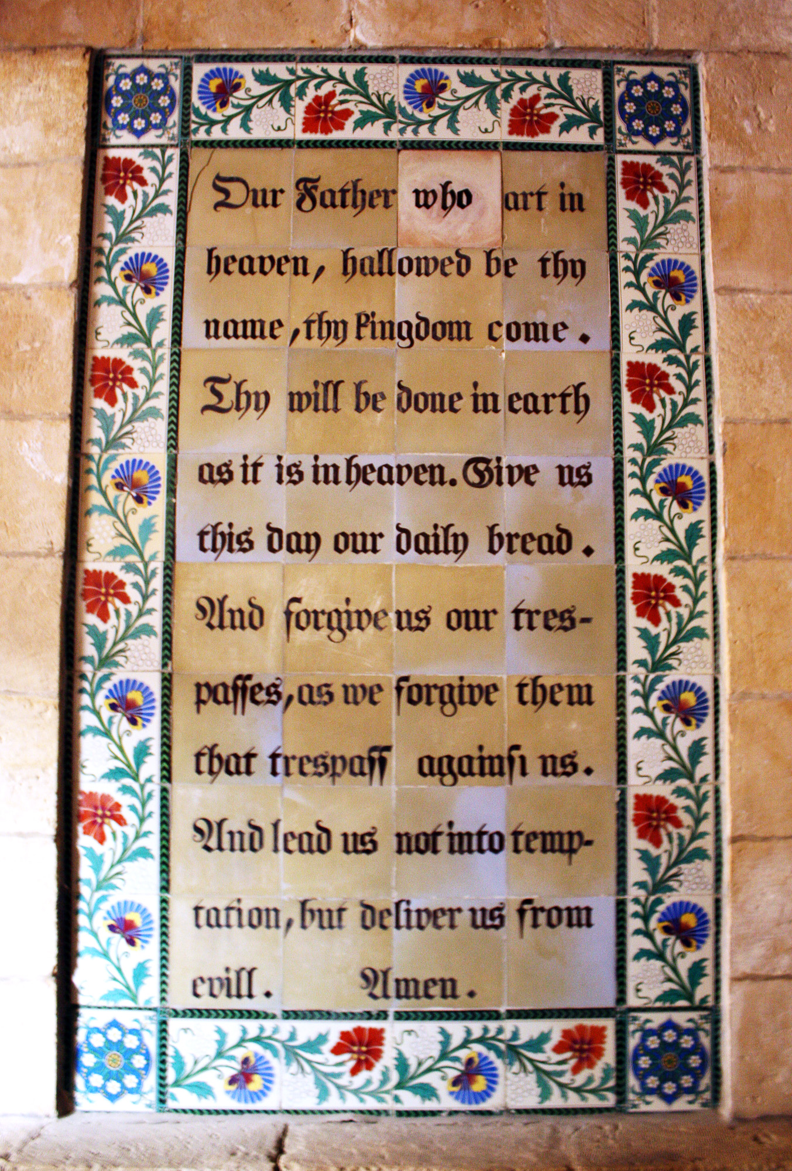
Hallowed be thy name.
Thy kingdom come, thy will be done
On earth as it is in heaven.
Give us this day our daily bread and forgive us our trespasses
As we forgive those who trespass against us.
And lead us not into temptation but deliver us from evil
For thine is the kingdom, the power and the glory
For ever and ever. Amen.

A song to sing or reflect on:

1 Come down, O Love divine!
seek out this soul of mine
and visit it with your own ardour glowing;
O Comforter, draw near,
within my heart appear,
and kindle it, your holy flame bestowing.

2 There let it freely burn
till earthly passions turn
to dust and ashes in its heat consuming;
and let your glorious light
shine ever on my sight,
and make my pathway clear, by your illuming.

3 Let holy charity
my outward vesture be,
and lowliness become my inner clothing;
true lowliness of heart
which takes the humbler part,
and for its own shortcomings weeps with loathing.

4 And so the yearning strong
with which the soul will long
shall far surpass the power of human telling;
for none can guess its grace
till we become the place
in which the Holy Spirit makes his dwelling.

Closing prayers
Spirit of life
ALL: Fill our emptiness with your fullness
Spirit of power
ALL: Stir our hearts afresh
Spirit of love
ALL: Touch us, and through us, our neighbour
Spirit of Creativity
ALL: Enable and empower the gifts you have given
Spirit of Eternity
ALL: Draw us ever deeper into your Kingdom

God of power,
May the boldness of Your Spirit transform us,
May the gentleness of Your Spirit lead us,
May the gifts of your Spirit equip us
To serve and worship You, now and always. Amen.

Go in peace to love and serve the Lord.
Thanks be to God.

