Father Image

Resource for worship week 12
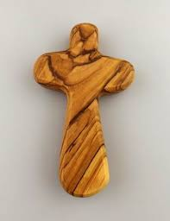

You will need a cross and a photo of your father/ grandfather/ parent.

Opening verse:
‘See what great love the Father has lavished on us, that we should be called children of God!’
1 John 3:1

Read through slowly the verses from Psalm 146 below:

Praise the Lord. Praise the Lord, my soul.
I will praise the Lord all my life; I will sing praise to my God as long as I live.
He is the Maker of heaven and earth, the sea, and everything in them—
He remains faithful forever. He upholds the cause of the oppressed and gives food to the hungry.
The Lord sets prisoners free, the Lord gives sight to the blind, the Lord lifts up those who are bowed down, the Lord loves the righteous.
The Lord watches over the foreigner and sustains the fatherless and the widow, but he frustrates the ways of the wicked.
The Lord reigns forever, your God, O Zion, for all generations. Praise the Lord.

Reflection:
Some of us have had very positive experiences of a father, whilst others may be much less fortunate. Whatever our experience, I believe there is a desire in us all, certainly as children, to be able to look up to our parent with pride, to see them as worthy of praise and love. It’s an expectation that is inherent in us all; we want our dad to be the best dad in the world.
When I think of God as Father, that same desire is awakened in me. When I read the psalm above I like to replace the phrase ‘the Lord’ with ‘My Father,’ for that is who he is. Through faith in Jesus I have become a child of God and he has become my Father in heaven. So the psalm now reads:
Praise my Father. Praise my Father, my soul. I will praise my Father all my life; I will sing praise to my God as long as I live. He is the Maker of heaven and earth, the sea, and everything in them— He remains faithful forever. He upholds the cause of the oppressed and gives food to the hungry. My Father sets prisoners free, my Father gives sight to the blind, my Father lifts up those who are bowed down, my Father loves the righteous. My Father watches over the foreigner and sustains the fatherless and the widow, but he frustrates the ways of the wicked. My Father reigns forever.

How awesome and wonderful is the God whom we can call Father!! Consider the world he has made; reflect on his faithfulness. Think on his goodness, his love and care for all who look to him in their need. Our Father who dwells in the highest heaven looks upon us with mercy, justice and love.

Prayer Activity
Take a moment to contemplate the majesty of God and his love towards you. Take hold of the picture of ‘a father figure in your life,’ one who has protected you, comforted and guided you, loved you and cared for you. Through their life we glimpse the fatherhood of God.
Give thanks for them. Pray for your own circumstances, for those entrusted to your care, for the pressures you feel under and for the opportunities you have to share God’s love.

You may wish to pray the following prayer:

Almighty God, my Eternal Father, from the fullness of my soul I adore You.
I am deeply grateful that You have made me in Your image and likeness,
and that You ever hold me in Your loving embrace.
Direct me to love You with all my heart,
with all my soul, and with my whole mind.
Direct me to love all Your children as I love myself.
O, my Father, my soul longs to be united to You, and to rest in You forever.
Have the Holy Spirit touch my soul so that I may love You as He does,
and as Your Beloved Son Jesus does. Amen.

Poem: I’ve a Father in heaven - Rev. Dean Beaty

I’ve a Father who hears me whenever I call.
I can bring Him my problems whether great or small.
And I know that He hears and He’s touched by my tears
For my Father in heaven is the great KING OF KINGS.

I’ve a Father who keeps me, I’m held in His hand.
Though life’s trials may test me, He will help me to stand.
All the burdens and care, He will help me to bear.
For my Father in heaven, is the great KING OF KINGS.

I’ve a Father who loves me, though sometimes I fall.
He remembers my weakness and that I am so frail.
But He walks by my side, as my comfort and guide.
With my Father in heaven, I’m a child of the King.

I’m a child of the King, a child of the King.
With God as my Father, I’m a child of the King.

Time of prayer
O God, Father of all goodness and of all grace,
You are worthy of greater love than we can either give or conceive:
Fill our hearts with such love towards you
That all other things fade away
and we are caught up in the joy of heaven.
Grant that loving you, Lord,
we may daily be transformed into your image
loving and being loved, now and for ever.
Lord, in your mercy
Hear our prayer.

Most loving Father,
Help us to see one another through your eyes,
to hear one another through your ears
and to serve one another as with your hands.
May we be slow to criticise and quick to care
Slow to judge and quick to comfort.
Keep us from all prejudice and all pride
That in humility we may be a blessing to all
Lord, in your mercy
Hear our prayer.

Lord of wisdom,
We pray for our government, our leaders
and those who make policies.
Grant them wisdom and humility
That they may diligently serve our nation
And faithfully guide our communities
Through this difficult time.
Lord, in your mercy
Hear our prayer.
Lord Jesus, we pray for our schools and colleges
Bless our teachers and parents,
all pupils, both in school and at home,
at this unprecedented time.
Provide for their learning,
Support those who are struggling,
And comfort all who are anxious.
Lord, in your mercy
Hear our prayer.
God of all compassion
We pray for the sick, the lonely and those who feel forgotten:
Look upon them with lovingkindness
and carry them close to your heart,
that in all their suffering and all their troubles
they may experience your love.
Lord, in your mercy
Hear our prayer.
Let us commend ourselves and all for whom we pray
to the mercy and protection of God, in the prayer our Saviour taught us.

Our Father who art in heaven, Hallowed be thy name.
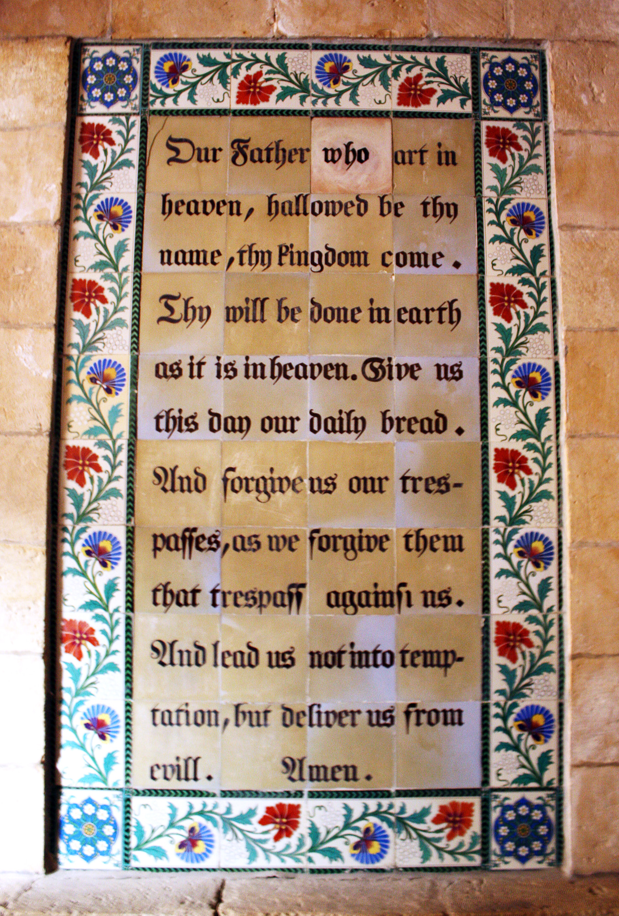
Thy kingdom come, thy will be done on earth as it is in heaven.
Give us this day our daily bread and forgive us our trespasses
As we forgive those who trespass against us.
And lead us not into temptation but deliver us from evil
For thine is the kingdom, the power and the glory
For ever and ever. Amen.

A song to sing or reflect on:

Dear Lord and Father of mankind
Forgive our foolish ways;
Reclothe us in our rightful mind;
In purer lives Thy service find,
In deeper reverence, praise (x2)

In simple trust like theirs who heard
Beside the Syrian sea,
The gracious calling of the Lord,
Let us like them, without a word
Rise up and follow Thee. (x2)

O Sabbath rest by Galilee!
O calm of hills above,
Where Jesus knelt to share with Thee
The silence of eternity,
Interpreted by love. (x2)

With that deep hush subduing all
Our words and works that drown
The tender whisper of Thy call,
As noiseless let Thy blessings fall
As fell Thy manna down. (x2)

Drop Thy still dews of quietness,
Till all our strivings cease;
Take from our souls
The strain and stress,
And let our ordered lives confess
The beauty of Thy peace (x2)

Breathe through the heats of our desire
Thy coolness and Thy balm
Let sense be dumb, let flesh retire
Speak through the earthquake, wind and fire
O still, small voice of calm! (x2)

Closing prayers
Gracious God, you have given us much today:
Grant us also a thankful spirit.
Into your hands we commend ourselves and those we love.
Stay with us, and when we take our rest
Renew us for the service of your Son Jesus Christ. Amen.

May the Lord of peace himself
Give you peace at all times and in every way.
The Lord be with you all, for evermore. Amen.

