Cleanliness and Godliness

Resource for worship week 17

You will need a cross and a towel

Opening verse:
‘I will sprinkle clean water on you and you will be clean.’ Ezekiel 36:25

Read through slowly the familiar verses from John 13:1-5 below:

13 It was just before the Passover Festival. Jesus knew that the hour had come for him to leave this world and go to the Father. Having loved his own who were in the world, he loved them to the end.
² The evening meal was in progress, and the devil had already prompted Judas, the son of Simon Iscariot, to betray Jesus.
³ Jesus knew that the Father had put all things under his power, and that he had come from God and was returning to God;
⁴ so he got up from the meal, took off his outer clothing, and wrapped a towel around his waist.
⁵ After that, he poured water into a basin and began to wash his disciples’ feet, drying them with the towel that was wrapped around him.
Reflection:
It is said that ‘cleanliness is next to godliness,’ and over the past few months we have been encouraged and even cajoled into washing our hands and doing our utmost to be clean. In our schools, children are to wash their hands every 15-20 minutes. When we enter and leave shops, we are to use hand sanitizer, when we leave and return home, we are to make sure our hands are clean. Food preparation especially requires clean hands, should there be any doubt. Every activity is to preceded and followed by hand washing!

The Israelites had the same strict hygiene measures, having specific regulations regarding the many situations in which one might become unclean. Indeed, being clean externally highlighted the importance of being clean inwardly, having a clean heart and pure thoughts. As Jesus explained to his disciples, ‘it is what comes out of a person that makes them unclean.’
Jesus washed the feet of his disciples, which was the job of a slave. But Jesus was enacting a living parable to explain what he was about to do. He had come as a slave to cleanse us all from our sins, which make us dirty on the inside.

After he had washed their feet, he wiped them with a towel wrapped around his waist. The towel symbolized that he would fully complete the task and perform his duty humbly and faithfully.

Prayer Activity
Take the towel and hold it in your hands. You may want to think back to when you were a child and your mum or dad used to dry you with a towel. Perhaps you recall being wrapped up in a towel after a bath. Think about the softness of the towel and the feeling of being clean and safe. Reflect on how Jesus has come to wash our sins away and to wrap us up in his love. He will not leave us wet and shivering but will ensure we are dry and safe. Take a moment to bring to him all your sins, of thought and speech and action. Allow him to wash you clean and take you to himself.
Pray for grace that you might similarly wash another’s feet by forgiving them and loving them.

You may wish to pray the following prayer:

Lord Jesus, faithful Saviour
In the upper room, you were alone with your disciples.
Humbly, lovingly,
you stooped down to wash their feet in turn.
Carefully, tenderly,
you wiped their feet dry, with the towel round your waist.
Prayerfully, penitently,
I ask you would do the same for me this night.
Graciously, mercifully
Cleanse me from my sins and embrace me with your forgiveness.
Powerfully, wonderfully,
Take me up in your arms and bear me close to your heart.
Humbly, lovingly,
Help me to stoop to wash my neighbour’s feet. Amen.

The touch of the towel - Lisa Ann Moss Degrenia

Jesus, you kneel before me
You remove my shoes and I am exposed
My feet are grimy
full of calluses and cracks
pungent with sweat and toe jam
I’m embarrassed by them
I pull back but you reassure
You’re not offended
I feel welcome in your hands
vulnerable, yet safe
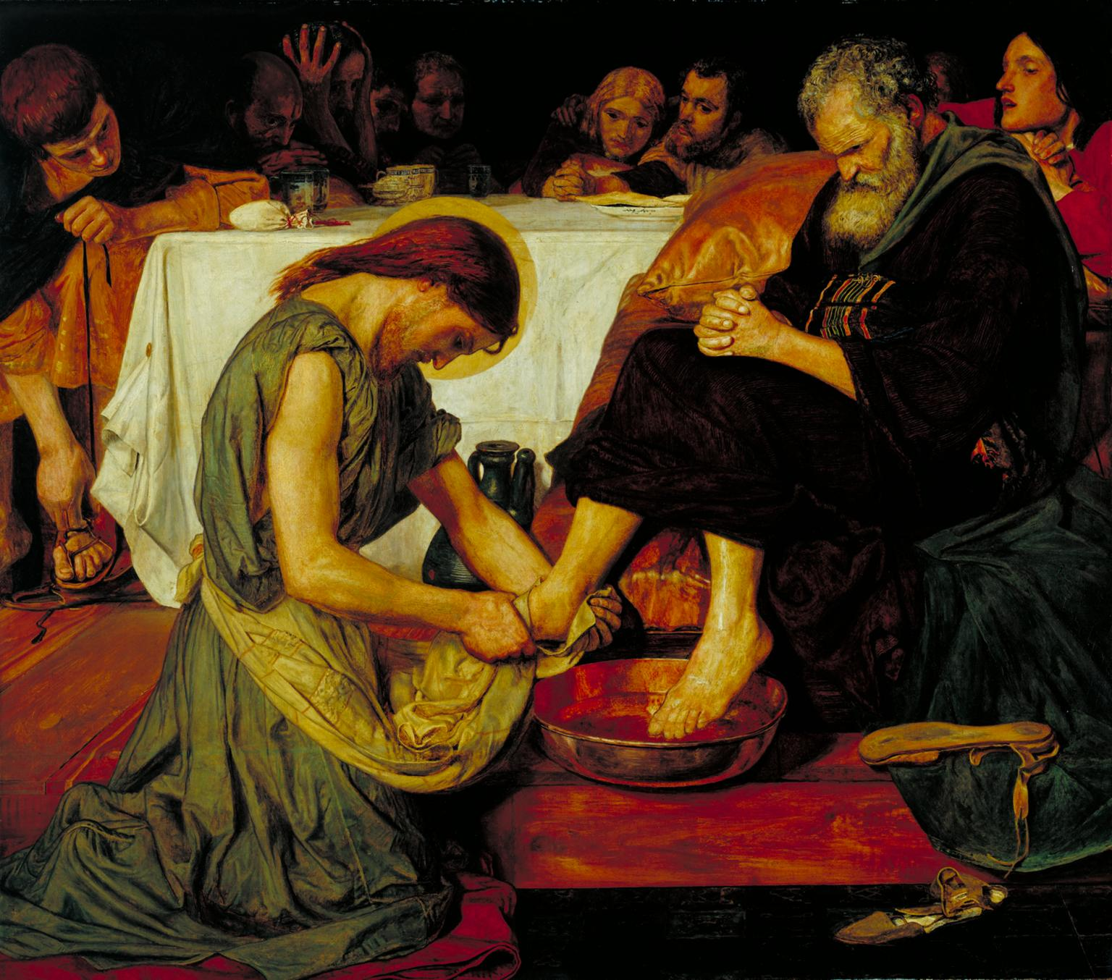
The cleansing begins
I see your reflection in the ripples
I see me, too
Your water brings truth and life
Who I am and who I can be
I am whole and home in the touch the towel
You look at my neighbour and hand it to me

Time of prayer
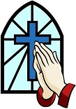

We pray that Christ may be seen in the life of the Church.
Jesus, Lord of the Church,
in your mercy, hear us.

You have called us into the family of those who are the children of God.
May our love for our brothers and sisters be strengthened by your grace.
Jesus, Lord of the Church,
in your mercy, hear us.

You have called us to be a temple where the Holy Spirit can dwell.
Give us clean hands and pure hearts, so that our lives will reflect your holiness.
Jesus, Lord of the Church,
in your mercy, hear us.

You have called us to be a light to the world, so that those in darkness come to you.
May our lives shine as a witness to the saving grace you have given for all.
Jesus, Lord of the Church,
in your mercy, hear us.

You have called us to be members of your body, so that when one suffers, all suffer together.
We ask for your comfort and healing power to bring hope to those in distress.
Jesus, Lord of the Church,
in your mercy, hear us.

You have called us to be the Bride, where you, Lord, are the Bridegroom.
Prepare us for the wedding feast, where we will be united with you for ever.
Jesus, Lord of the Church,
hear our prayer,
and make us one in heart and mind
to serve you with joy for ever. Amen.

Merciful God, you have prepared for those who love you
Such good things as pass our understanding;
Pour into our hearts such love toward you
That we, loving you in all things and above all things,
May obtain your promises,
Which exceed all that we can desire;
Through Jesus Christ your Son our Lord. Amen.

Let us commend ourselves and all for whom we pray
to the mercy and protection of God, in the prayer our Saviour taught us.

Our Father who art in heaven,
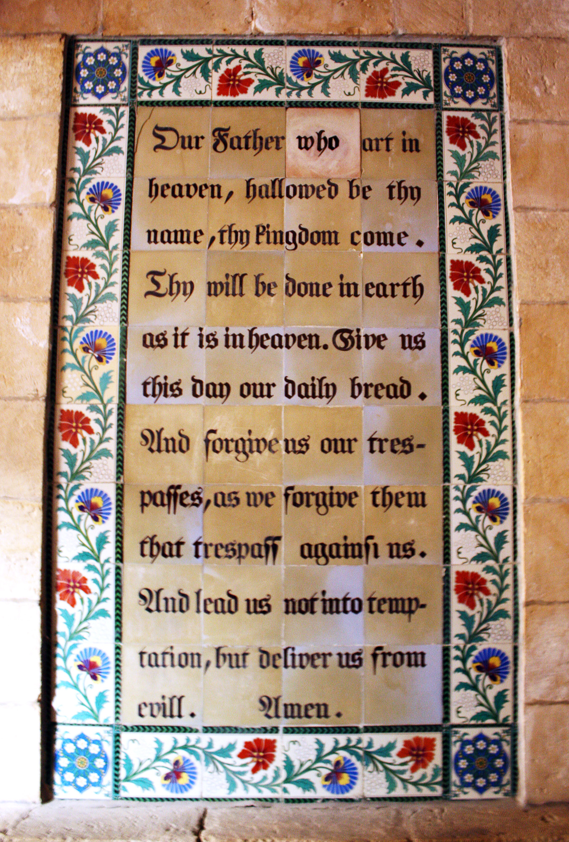
Hallowed be thy name.
Thy kingdom come,
thy will be done on earth as it is in heaven.
Give us this day our daily bread
and forgive us our trespasses
As we forgive those who trespass against us.
And lead us not into temptation
but deliver us from evil
For thine is the kingdom,
the power and the glory
For ever and ever. Amen.

A song to sing or reflect on:

I heard the voice of Jesus say,
"Come unto me and rest;
lay down, O weary one, lay down
your head upon my breast."
I came to Jesus as I was,
weary and worn and sad;
I found in him a resting place,
and he has made me glad.

I heard the voice of Jesus say,
"Behold, I freely give
the living water; thirsty one,
stoop down and drink, and live."
I came to Jesus, and I drank
of that life-giving stream;
my thirst was quenched, my soul revived,
and now I live in him.

I heard the voice of Jesus say,
"I am this dark world's Light;
look unto me, your morn shall rise,
and all your days be bright."
I looked to Jesus and I found
in him my Star, my Sun;
and in that light of life I'll walk,
'til trav'ling days are done.

Closing prayers
May Christ,
who overcame sin and death, being raised to new life,
fill you with renewed hope and joy. Amen.

Go in peace to love and serve the Lord.
Thanks be to God.

